

UNIVERSITY OF PETROLEUM & ENERGY STUDIES
Dehradun

CONTINOUS INTEGRATION
AND
CONTINOUS DELIVERY

Experiment 2

Name: Madhav Bhatia
Course: B. TECH CSE DevOps (2018-22)
Roll no.: R171218061
Sapid: 500068227

Experiment-2
Jenkins Integration with GitHub

Step-1: Open terminal and type the command to run the Jenkins.
“$ /etc/init.d/jenkins start”
Type localhost:8080 in the browser to run the Jenkins and login.

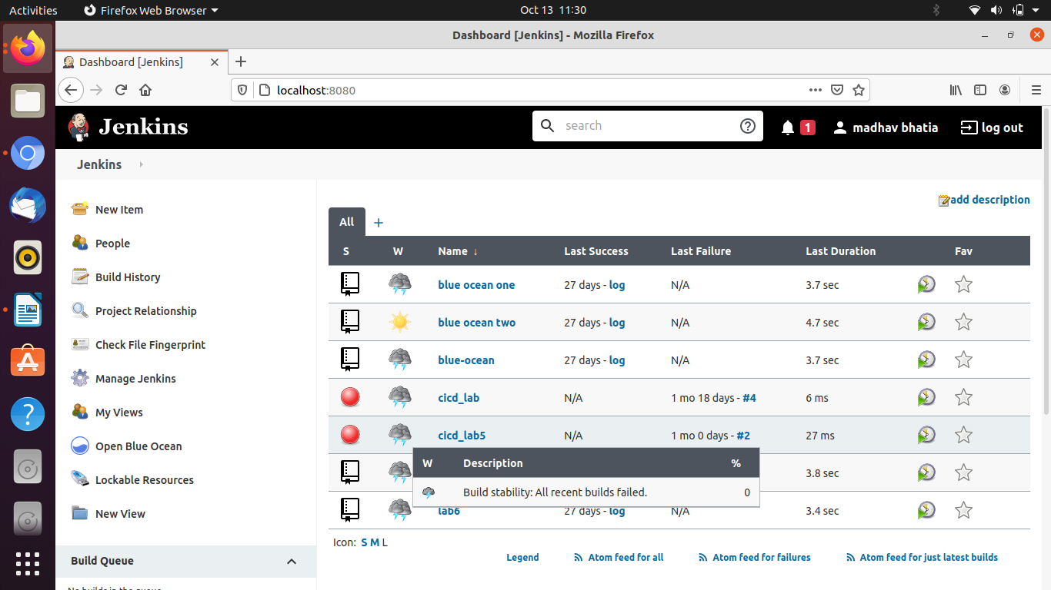

Step-2: Click on the new item to create a new freestyle project and specify the name and click ok.

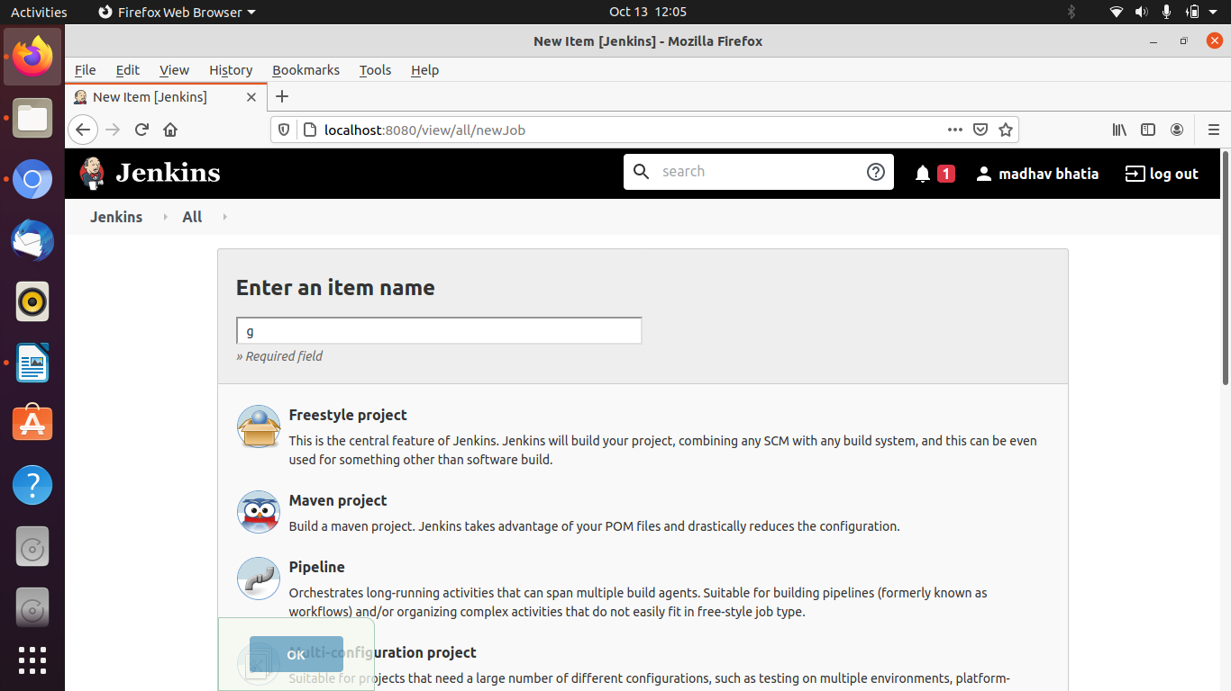

Step-3: Now make further settings. Go to source code management, Click on git and provide the URL of the GitHub repository.

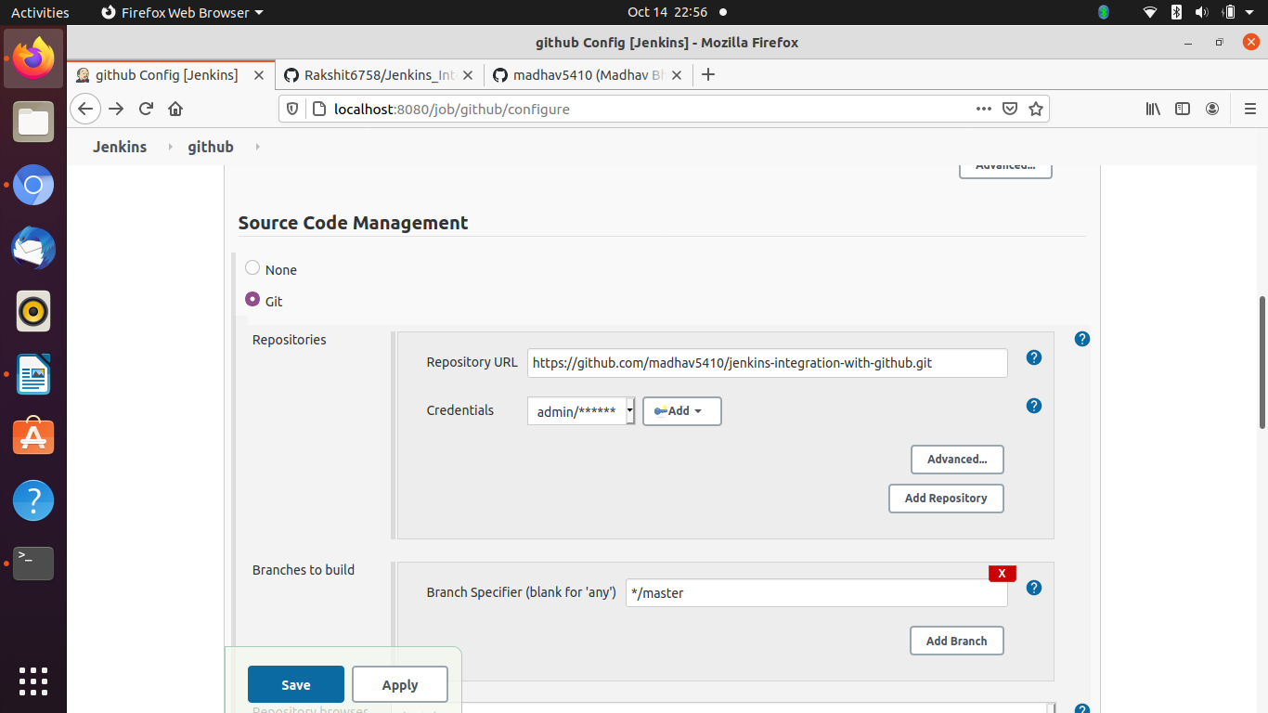

Step-4: Click on save button and your Jenkins is integrated with GitHub for that repository.

